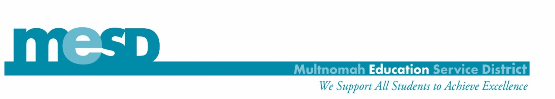

MESD Assistive Technology Department Evaluation Consent Form
The Multnomah Education Service District Assistive Technology department has received a team referral to initiate an assistive technology evaluation for the student listed below:

Student Name:

School Program:

According to the referral submitted by your student’s school case manager, the following areas of assessment are proposed to consider for Assistive Technology needs / services:
- Academics (e.g., reading, writing, math, learning / studying, or: )
- Communication
- Access
- Other:

The Assistive Technology and Augmentative/Alternative Communication Evaluation is a process that may include multidisciplinary consultation, school or community observations, trials of equipment and/or strategies, collecting documentation, and ongoing assessment, in order to:

  - Determine the need for assistive technology.
  - Share information regarding technology resources.
  - Assist in the process of obtaining appropriate technology for trials.
  - Train the use of equipment and/or strategies.
  - Facilitate the collection of data within the school or community setting.
  - Collect documentation of positioning and/or student utilization of equipment for assessment or training purposes, (e.g., video and pictures)
  - Consultation to staff to support student’s implementation of assistive technology equipment and/or strategies.

Parent / Guardian:
I hereby give permission for MESD to evaluate my student’s AT/AAC needs

date:

Parent / Guardian print name:

Parent / Guardian signature:

