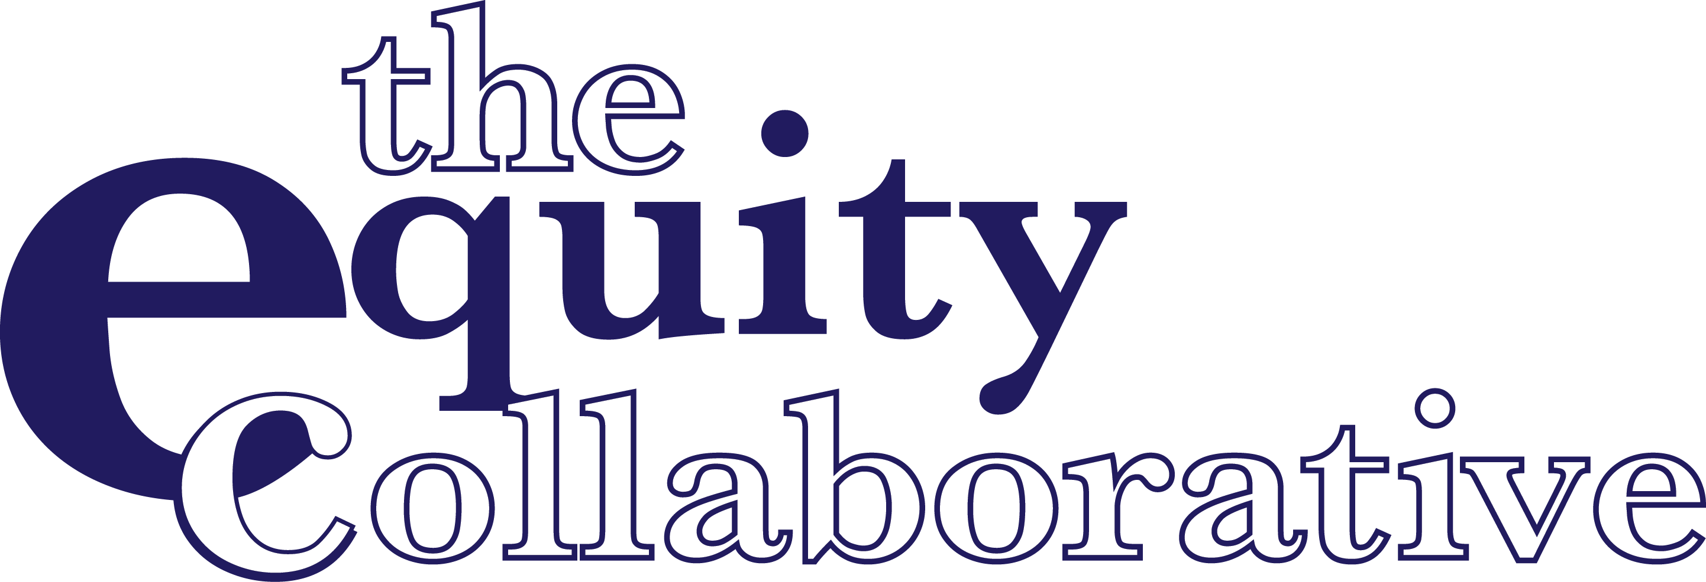

MULTNOMAH EDUCATION SERVICE DISTRICT & BARS TO BRIDGES
BUILDING BRIDGES TO EQUITY CULTURALLY RESPONSIVE LEADERSHIP AND TEACHING
APRIL 16, 2019

Jamie Almanzán jalmanzan@theequitycollaborative.com www.theequitycollaborative.com

Jamie Almanzán
Cell # 510-967-4705

Twitter @jalmanzan

Text questions or comments at any point during the session

Here’s what we are going for . . .
Session Outcomes
- Engage in discussion about oppression and education and examine assumptions about bias, privilege, change, and learning
- Examine an analytic of racialized systemic power in order to better catalyze change in institutional policies and practices
- Consider listening as a culturally responsive leadership and teaching skill to increase cultural proficiency and better diagnose challenges and support students to grow and learn

Equity Collaborative Transformation Frame

Equity and Oppression
Learning Theory and Culturally Responsive Teaching

Coaching and Facilitation

STARTING WITH THE WHY

WHAT

HOW

OUTSIDE IN/CONVENTIONAL
WHY
INSIDE OUT/REMARKABLE

“How Great Leaders Inspire Action,” Simon Sinek, The Golden Circle

The Problem to Solve
To achieve educational equity for the most underserved and marginalized students, there is a need to close the
Opportunity Gap
not just one of its outcomes...
the Achievement Gap.

Working towards equity means…

Eliminating the predictability of success and failure that currently correlates with any social or cultural factor
Interrupting
inequitable practices, challenging biases, and creating inclusive school environments for all

What Gets in the Way
There’s a gap between our intention for a quality education for every child,
and the actions we take and conditions we provide,
that prevent students from succeeding to their full potential.

What Gets in the Way How do well- intentioned individuals create inequity for students and families?

What is Implicit or Unconscious Bias?
Implicit bias is defined as the mental process that creates unconscious associations and attitudes toward things, actions, people and groups of people based on identified characteristics. (With people, we may focus on characteristics such as race, ethnicity, gender, age, appearance, sexual orientation, etc.)

The IMPACT of Implicit Bias
Unconscious biases toward our students and families will cause us to create and offer support and OPPORTUNITIES that are inequitable, thus creating a privileged system for some and an oppressive system for others.

To achieve educational equity for the most underserved and marginalized students, there is a need to close the
Opportunity Gap

Small Group Prompt

In what ways do you currently talk about the
impact of implicit biases on the students and families we serve?

Levels of Oppression

Individual
Institutional
Systemic or Structural

Stretch Break

Small Group Discussion
Where do your negative implicit biases show up? What are you able to detect about your own?

Why do you believe inequity and oppression in school are maintained?

How do your multiple identities combine to create the way that you view oppression and equity?

From Implicit Bias to Cultural Schema
- Implicit bias is the information categorization process of creating neural pathways

- Neural pathways (or habits) determine our beliefs, attitudes, and behaviors

- Multiple neural pathways create a singular cultural schema

- Collective beliefs, attitudes, and behaviors create a collective cultural schema

Critical Race Theory
Deﬁnition:
CRT analyzes the role of race and racism in perpetuating social disparities between dominant and marginalized racial groups. (DeCuir & Dixson; Ladson-Billings; Ladson-Billings & Tate, 1995)

CRT’s purpose is to unearth what is taken for granted when analyzing race and privilege, as well as the profound patterns of exclusion that exist in U.S. society. (Parker & Villalpando, 2007)

Critical Race Theory
- Counter-Storytelling
- Permanence of Racism
- Whiteness as Property
- Interest Convergence
- Critique of Liberalism

Critical Race Theory
Counter-Storytelling
DeCuir and Dixson stated that counter-stories are a resource that both expose and critique the dominant (male,White, hetero- sexual) ideology, which perpetuates racial stereotypes. Counter-stories are personal, composite stories or narratives of people of color (Delgado Bernal & Villalpando, 2002).

Critical Race Theory
Counter-Storytelling
The idea of storytelling comes from its powerful, persuasive, and explanatory ability to unlearn beliefs that are commonly believed to be true. CRT calls this concept “storytelling” and “counter- storytelling.” This dichotomy—storytelling and counter-storytelling
—is predicated upon the belief that schools are neutral spaces that treat everyone justly; however, close examination refutes this: simply evaluating graduation rates accomplishes this. School curricula continue to be structured around mainstream white, middle-class values.There continues to be a widening racial achievement disparities.

Critical Race Theory
Permanence of Racism
The permanence of racism suggests that racism controls the political, social, and economic realms of U.S. society. In CRT, racism is seen as an inherent part of American civilization, privileging White individuals over people of color in most areas of life, including education (DeCuir & Dixson, 2004; Delgado, 1995; Ladson-Billings, 1998;
Ladson-Billings & Tate, 1995

Critical Race Theory
Whiteness as Property
Due to the embedded racism in American society, Whiteness can be considered a property interest (DeCuir & Dixson, 2004). As a result, this notion operates on different levels. These include the right of possession, the right to use and enjoyment, the right to disposition, and the right of exclusion (DeCuir & Dixson; Ladson-Billings & Tate, 1995; Ladson-Billings, 1998).

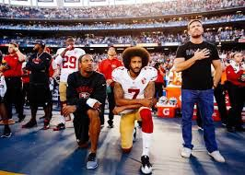
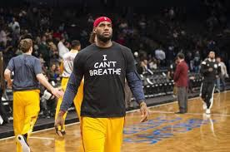
Critical Race Theory

I believe in free speech… just not like this. or this.

Critical Race Theory
Interest Convergence
Interest convergence is the notion that whites will allow and support racial justice/progress to the extent that there is something positive in it for them, or a “convergence” between the interests of whites and people of color.

This tenet acknowledges White individuals as being the primary beneﬁciaries of civil rights legislation (Ladson- Billings, 1998; DeCuir & Dixson, 2004; McCoy, 2006). DeCuir and Dixson argued,“early civil rights legislation provided only basic rights to African Americans, and other people of color, rights that had been enjoyed by White individuals for centuries.These civil rights gains were in effect superﬁcial ‘opportunities’ because they were basic tenets of
U.S. democracy” (p. 28).

Interest Convergence
“This notion of interest-convergence is exempliﬁed in Malcolm’s experience on his ﬁrst day of school at Wells. He explained: ‘The ﬁrst day I came as a freshman, before anybody said hello or how are you or what’s your name, they asked me do I play football and what was my 40 time. What did I run the 40- meter dash in? And that seemed like the big thing that they were concerned about because just about all African-American males at my school serve some type of purpose on some athletic team. That’s a horrible stereotype [regarding] African Americans. That’s a small glimpse of what we are capable of and what we can do. We’re smart. We can hold our own in the classroom and everything else.
But they expect us just to be Black athletes. That’s what I think they see coming in.‘“ (p.28)

Critical Race Theory

Critique of Liberalism
Critique of liberalism, stems from the ideas of color-blindness, the neutrality of the law, incremental change, and equal opportunity for all (DeCuir & Dixson, 2004).

Critical Race Theory

Critique of Liberalism
“Color-blindness” and “Meritocracy” allow whites to feel consciously irresponsible for the hardships people of color face and encounter daily and also maintain whites’ power and strongholds within society.

Critical Race Theory
Critique of Liberalism
First, color-blindness legitimizes racism’s need for an “other” in order to ﬂourish and maintain its inﬂuence within the fabric of society. Racism and white supremacy are not aberrant, insofar as the oppressors—the status quo—exploit the “others” (the oppressed) in order to maintain elitist control, as well as to claim that they are neutral. Close examination repudiates this false sense of neutrality.

Connections Across Roles
- Speak if you want to.
- Don’t speak if you don’t want to.
- Speak only once until everyone who wants to has had a chance to speak.
- Listen and note what people say, but do not respond. Connections is not the time to engage in a discussion.

Connections Across Roles
Discussion Question One:
Where in our school or district do we see examples of the tenets of Critical Race Theory in action?

But First… What is culture?
Culture is a system of shared behaviors, beliefs, customs, values, and ways of knowing that guide groups of people in their daily life and are transmitted from one generation to the next. Culture is the “language” of people’s thinking, feeling and behavior.

Culturally Responsive Teaching is the ability to recognize differences based on CULTURE, (language, race, ethnicity, gender and other aspects of individual identity) and to respond to those differences in a productive way in order to foster student learning.

Culturally Responsive Listening

Let’s play a game…
How does the game of “Taboo” work?
A word or phrase you’re trying to get the “guesser” to say
Identified “Taboo” words that cannot be used

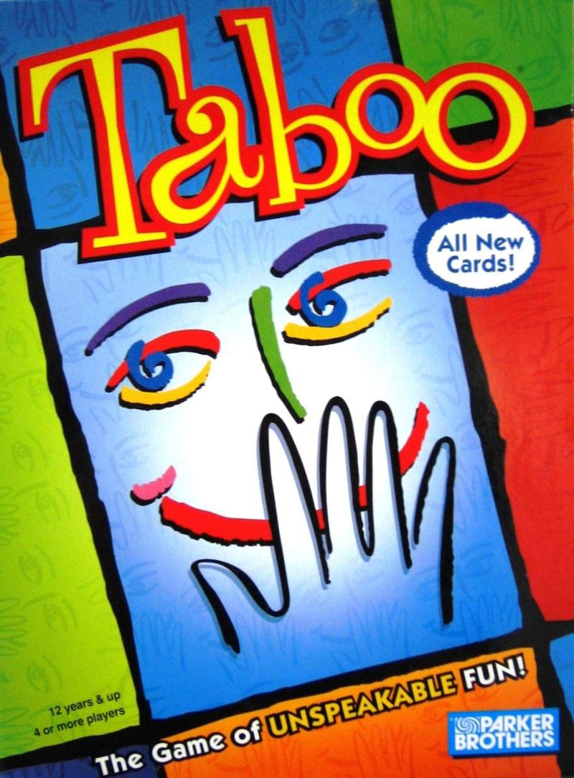
Culturally Responsive Listening

Ruby Slippers
Dorothy Kansas
Judy Garland Shoes
Wicked Witch

Culturally Responsive Listening

Let’s play a game…
How does the game of “Taboo” work?
- Three Roles…
- A clue giver
- A guesser
- A Taboo “proctor”

Culturally Responsive Listening

Peak | Stress | Boardwalk | Pretzel
Summit Mountain Point Career Shape | Nervous Tense Pressure Anxiety Work | Atlantic City Beach Pier Monopoly Park Place | Twisted Salty Snack Dough Mustard

Luau | Pomegranate | Menudo | Cornrows
Hawaiian Party Feast Roast Pig Hula | Fruit Bush Health Juice Red | Mexican Soup Tripe Holiday Hangover | African- American Hair Braid  Du-Rag Barbershop

Culturally Responsive Listening
Let’s play a game…
Clue Giver, what did you notice about your listening?

Guesser, when was there a time during the game that you felt like you were in “Cultural Sync” with the clue giver?

From Implicit Bias to Cultural Schema
- Implicit bias is the process of creating neural pathways
- Neural pathways (or habits) determine our beliefs, attitudes, and behaviors
- Multiple neural pathways create a singular cultural schema
- Collective beliefs, attitudes, and behaviors create a collective cultural schema

The Practice of Listening
“Constructivist Listening” Purposes:
It is valuable for us to be listened to as we inquire into emotional and intellectual demands of challenging inequity.
“Constructivist Listening” structures can serve as a practice space for the deep listening necessary to sustain our alliances across race, class, gender, language and other forms of difference.

“Constructivist Listening” Guidelines
- Each person is given equal time to talk
- The listener does not interrupt or break in with a personal story
- Confidentiality is maintained
- The talker does not criticize or complain about others during her/his time to talk

Dyad Prompt

What are your current strategies and structures that support listening to people? Who do you believe you need to listen to in order to address equity challenges? Why is that person/ those people important?

Dyad Prompt

Who do you struggle to listen to when addressing inequity? Who do you need to spend time listening to in order to address equity given your role?

Dyad Prompt

How confident in your own racial identity are you? What gives you that confidence? How comfortable are you in setting aside your identity to make room for someone else?

Teaching is Magic
Discussion Prompts: When was the last time you felt like you created magic for your learners?
How could you tell they felt wonder?

Max Ray Listening 2 > Listening 4
  - Eavesdrop (Think, Pair, Share) - Move through the room to listen, “Eavesdropping”, on students’ ideas, not correcting them or adding to their ideas. Them NOT you.
  - Tagging and Binning - Create constant opportunities for students to share their ideas. Organize students’ conversation and thinking to build on their ideas and help them understand the concepts/skills to be learned.
  - Giving students clear written feedback NOT connected to grading - Feedback cannot be solely connected to grading/evaluation. For your own growth, use video to create a self reflective feedback loop or peer observations for a collaborative feedback loop.

Microlab Reflection Protocol
A way to process our thoughts from the day

A way to practice our listening skills with a “working trio”

Microlab Reflection Protocol
  - Everyone has time to write in response to a given prompt.
  - Each member of the trio has two minutes to share what they wrote or what they’re thinking without interruption.
  - Repeat the process for the second and third prompts, each member of the trio sharing ﬁrst at some point.
  - Finish the protocol with time to discuss and respond to what they heard from each other.

Microlab Reflection Protocol
Prompt One: What has been your personal experience talking about equity and race at your school? What can be challenging? What has felt successful to you in the past?

Microlab Reflection Protocol
Prompt Two: In what structured ways do you currently “listen TO students and not FOR the right answer”? Reﬂecting on a lesson that you have already done, where have you (or could you have used) some of these strategies to better listen to your students?

Microlab Reflection Protocol

Prompt Three: What
skills or knowledge do you believe you need to learn/practice to be able to interrupt inequity?

Culturally Responsive Listening
Three Key Teaching Skills…
The skill of listening
- Listening for Cultural Schema that is different from yours to support YOUR OWN reflection and change
- Listening to cultural schema different from yours to support reflection, change and growth IN OTHERS based on THEIR identified goals

The Practice of Listening
"Being able to put aside one’s self-centered focus and impulses has social beneﬁts: It opens the way to empathy, to real listening, to taking another person’s perspective. Empathy… leads to caring, altruism, and compassion. Seeing things from another’s perspective breaks down biased stereotypes, and
so breeds tolerance and acceptance of differences.”
- Daniel Goleman

