DISRUPTING

The School to Prison Pipeline

Through an EQUITY LENS

Tyrone C. Howard, Ph.D. & Jaleel Howard
The Howard Group Multnomah County, OR February 27, 2020

Turn. Talk. Connect.

- Family

- Friends

- Travel

- Experiences

- Memories

Let’s Move from Safe Spaces to

Brave Spaces!

A safe space is ideally one that doesn’t incite judgment based on identity or experience - where the expression of both can exist and be affirmed without fear of repercussion and without the pressure to educate. While learning may occur in these spaces, the ultimate goal is to provide support.

A brave space encourages dialogue. Recognizing difference and holding each person accountable to do the work of sharing experiences and coming to new understandings - a feat that’s often hard, and
typically uncomfortable.

Our Stories Matter!

- When you tell a story you spark a connection !
- Stories stand the test of time.
- Stories are central to human cognition and communication. We engage with others through stories, and storytelling is a lot more than just a recitation of facts and events. Its personal!
- As human beings, we are automatically drawn to stories because we see ourselves reflected in them.
- We inevitably interpret the meaning in stories and understand ourselves, and others better.
- Relationships can be built and maintained through story!

Let’s Reflect, Remember, & Respond!

Why Does the School to Pipeline Matter:

- Children of color are 38% of youth (Colby & Ortman, 2015), but they are 70% of incarcerated juveniles in the US (Hockenberry, 2018).
- Schools play an active and participatory role in criminalizing our most vulnerable youth. Largely comprised of poor, traumatized, Black, and Latinx youth.

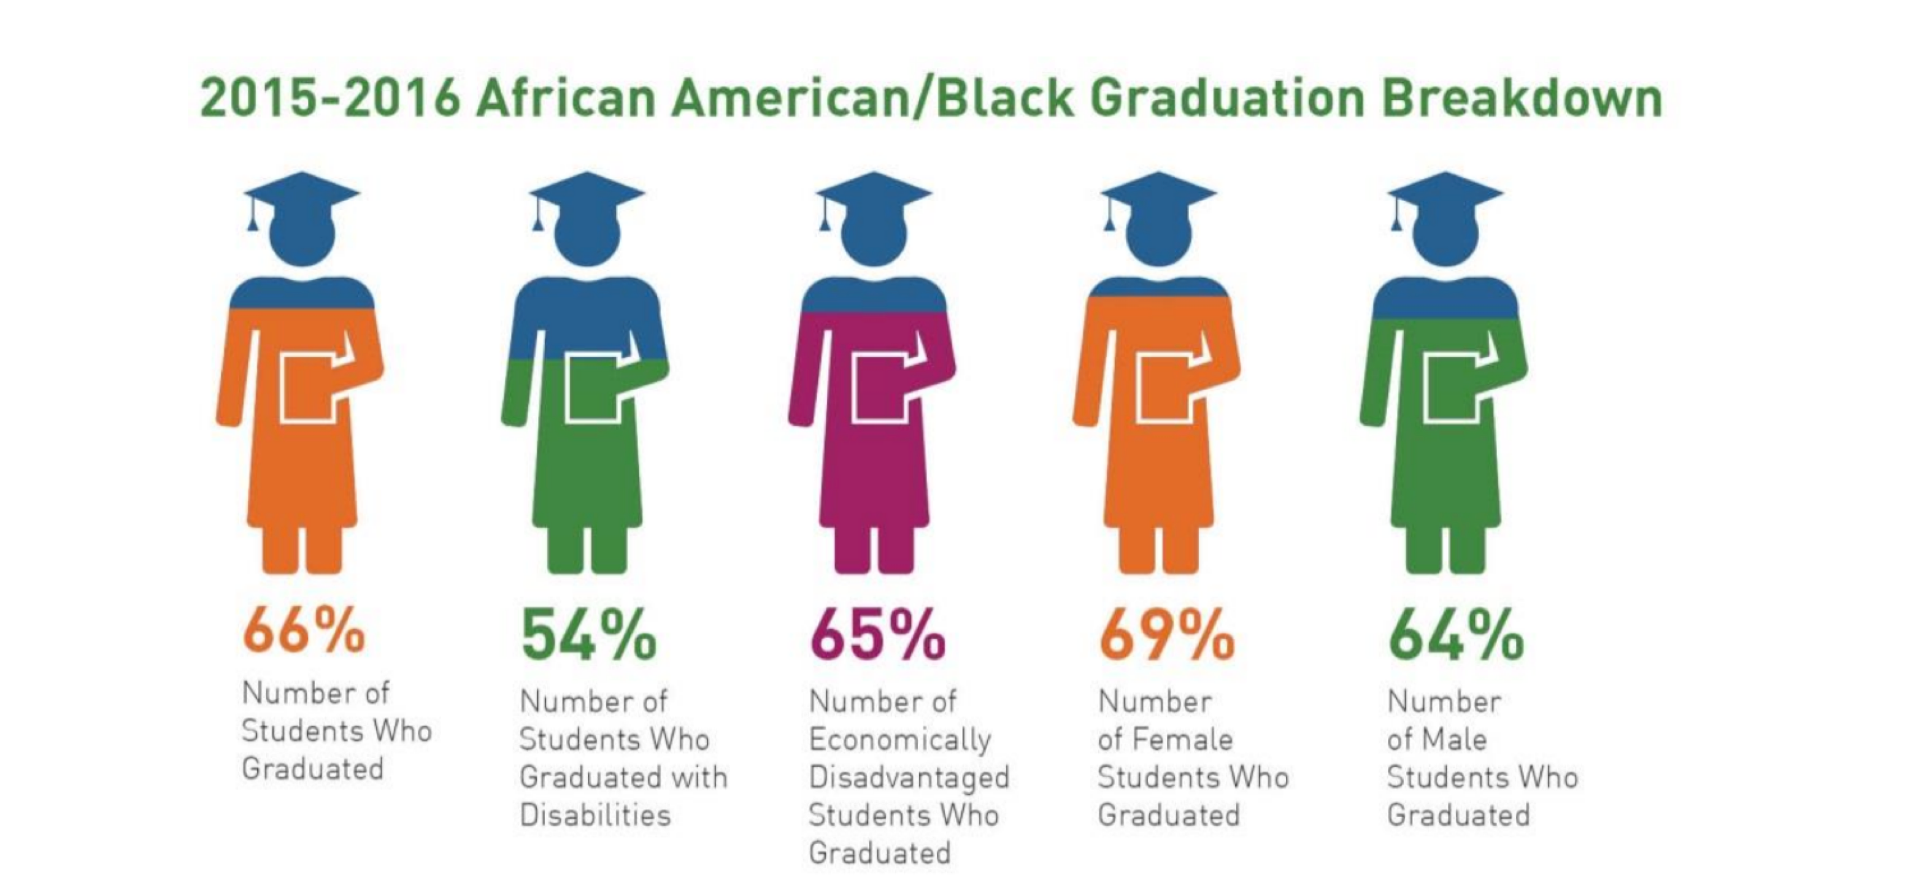
Oregon Department of Education Graduation Data

Four areas that we can address and do equity & disrupt the School to Prison Pipeline

- Discipline

- Talk Race

- Curriculum

- Relationships

THE CHALLENGE:

DISPARITIES IN SCHOOL DISCIPLINE
- Suspension rates for preschool children are uneven and unacceptable across the US.

- Black & Latino children represent 45 percent of preschool enrollment in the US but 72 percent of students suspended once, and 78% of students who are expelled from preschools.

Portland SD 1J | Portland, OR Discipline and GATE DATA 2017-2018

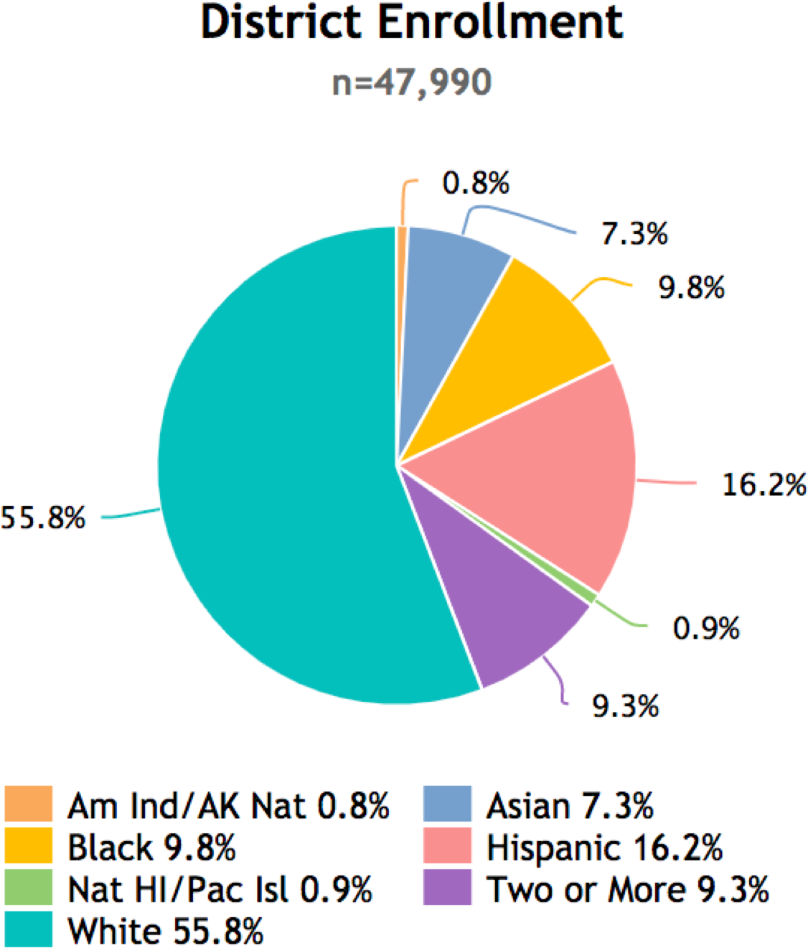
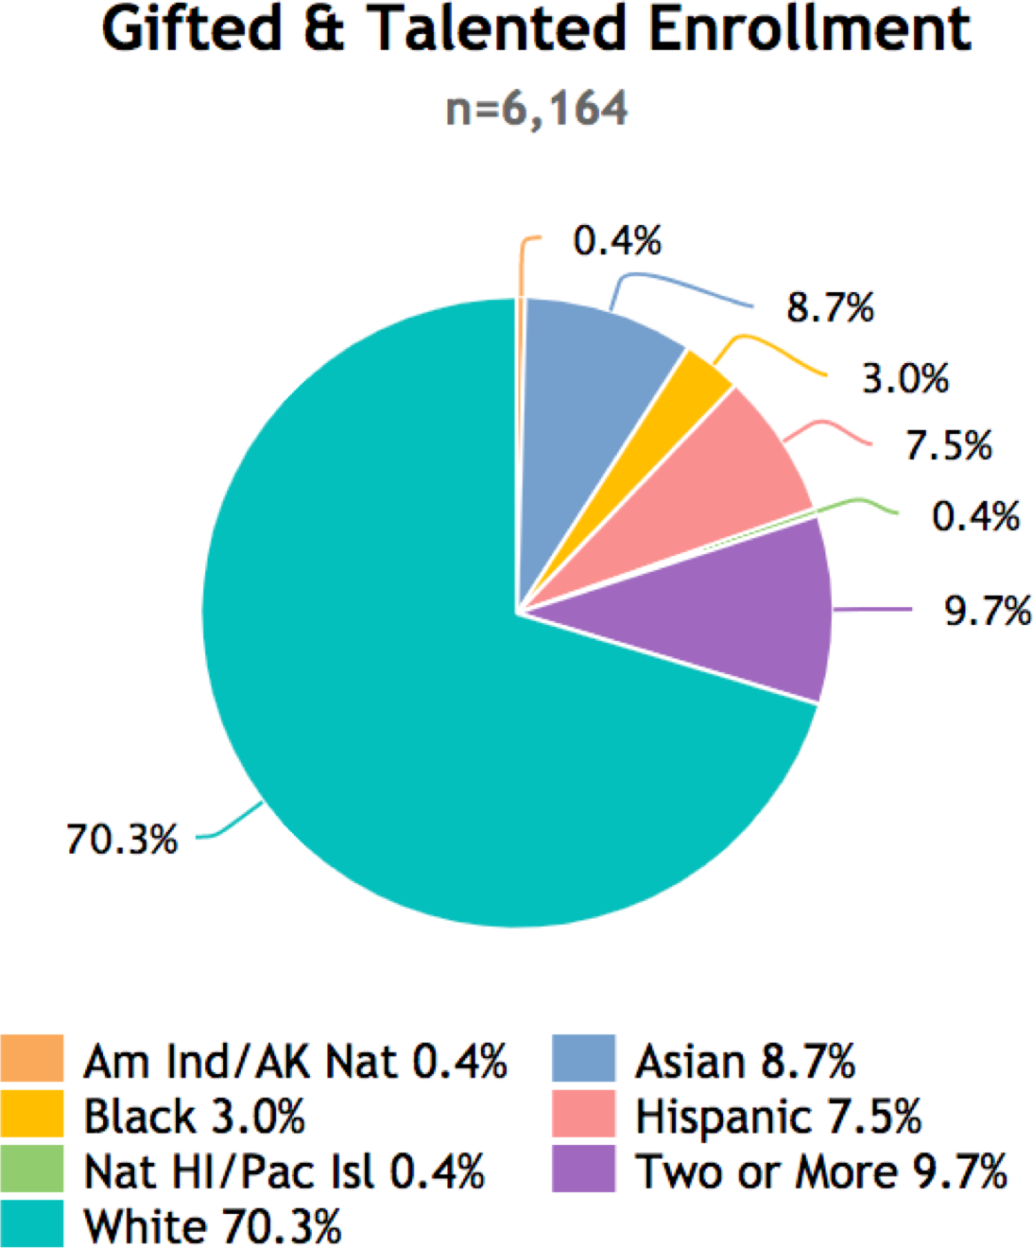
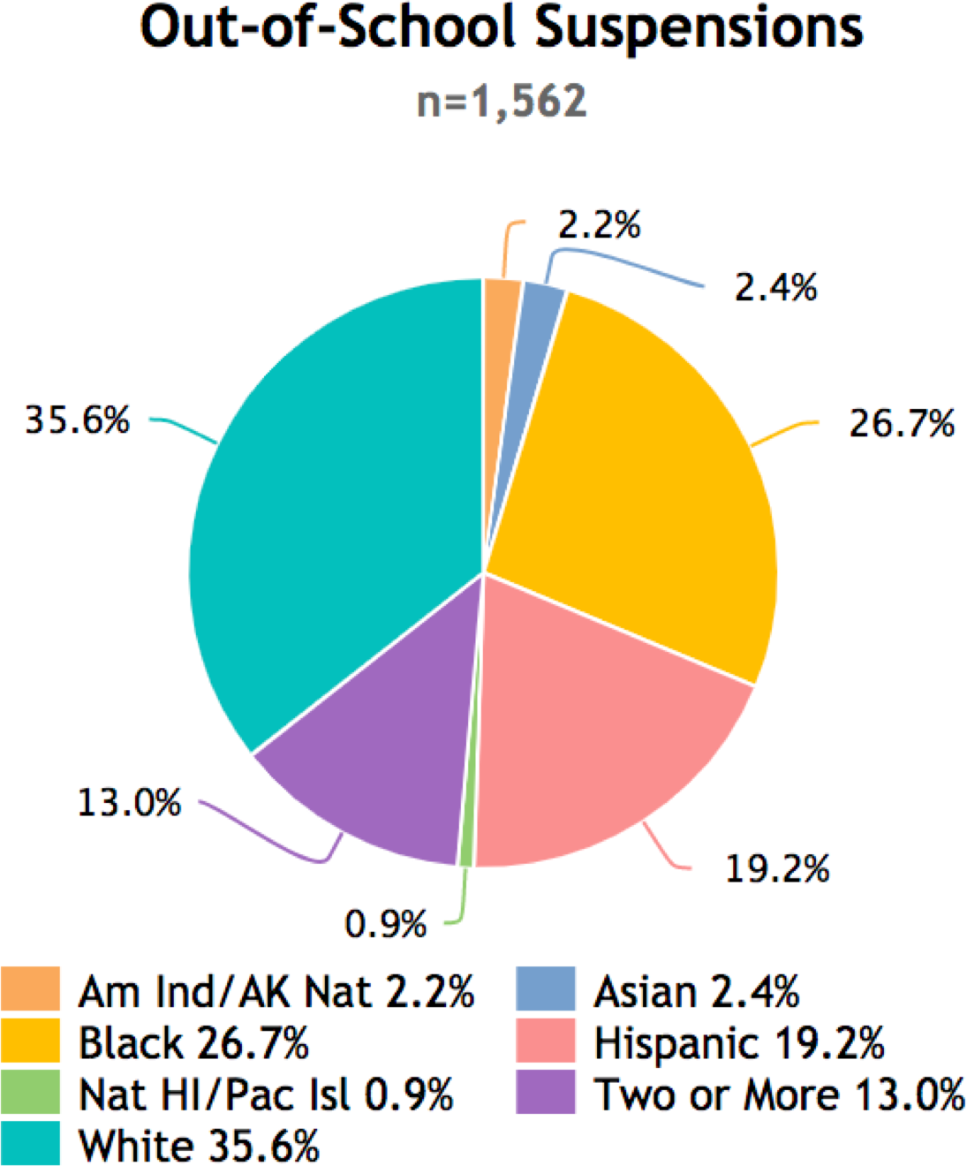

Reynolds SD 7 | Fairview, OR Discipline and GATE DATA 2017-2018
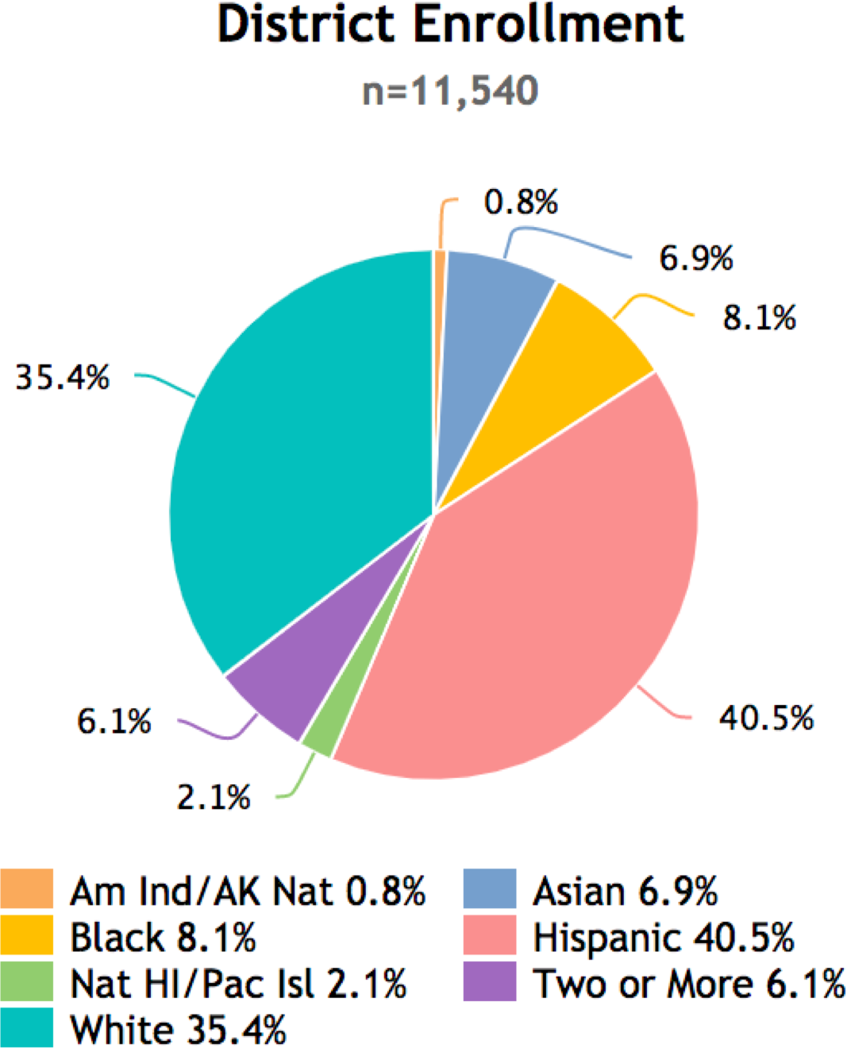
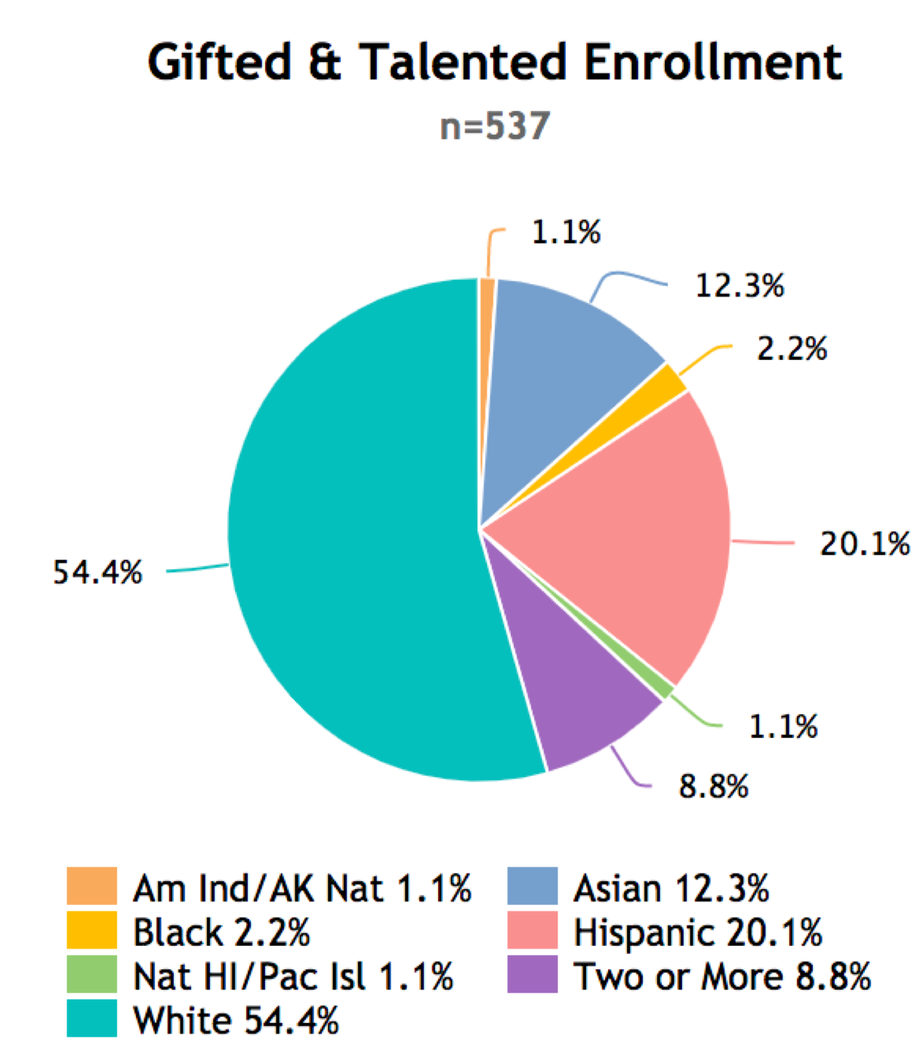
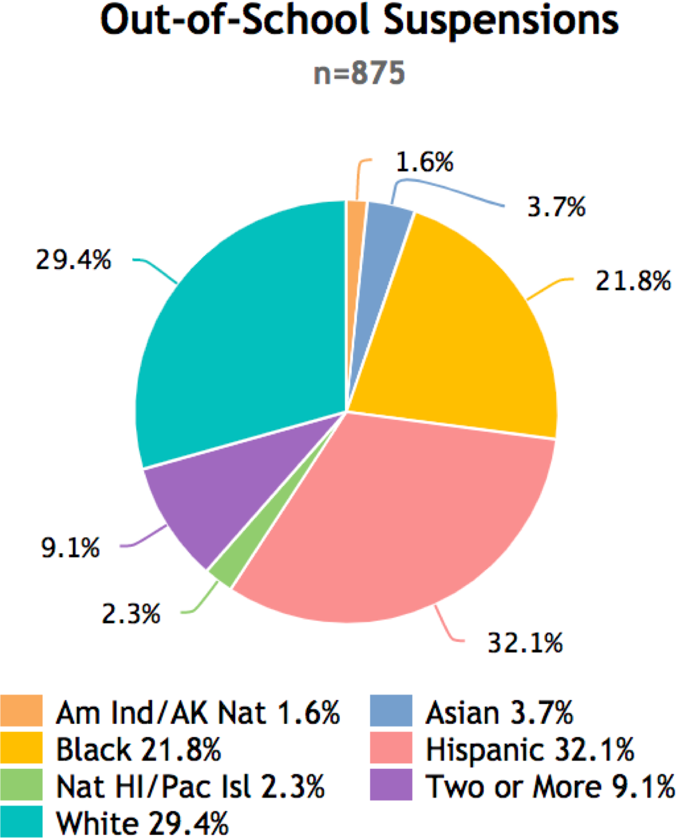

Disproportionality in School Discipline
- Tardiness
- Dress Code Violation
- Disrespect
- Defiance
- Drugs
- Weapons
- Fighting
- Chronic Absenteeism
- Truancy
- Threats
- Insubordination

Oregon Top Disciplinary Offense types

Insubordination – 13,891
- Violation of School Rules – 6,965
- Disorderly Conduct – 6,415
- Attendance Policy Violation – 6,161
- Combined, these represent 51% of all incidents

Suspension and the path to prison !

- Students who are suspended are more likely to fall behind in school
- Students who fall behind in school are more likely to be retained
- Students who are retained are more likely to be pushed out of school or less likely to graduate
- Students who do not graduate are more likely to get arrested or referred to the juvenile delinquency
- Those students are disproportionately male, of color, poor, and have mental challenges

Oregon Department of Education

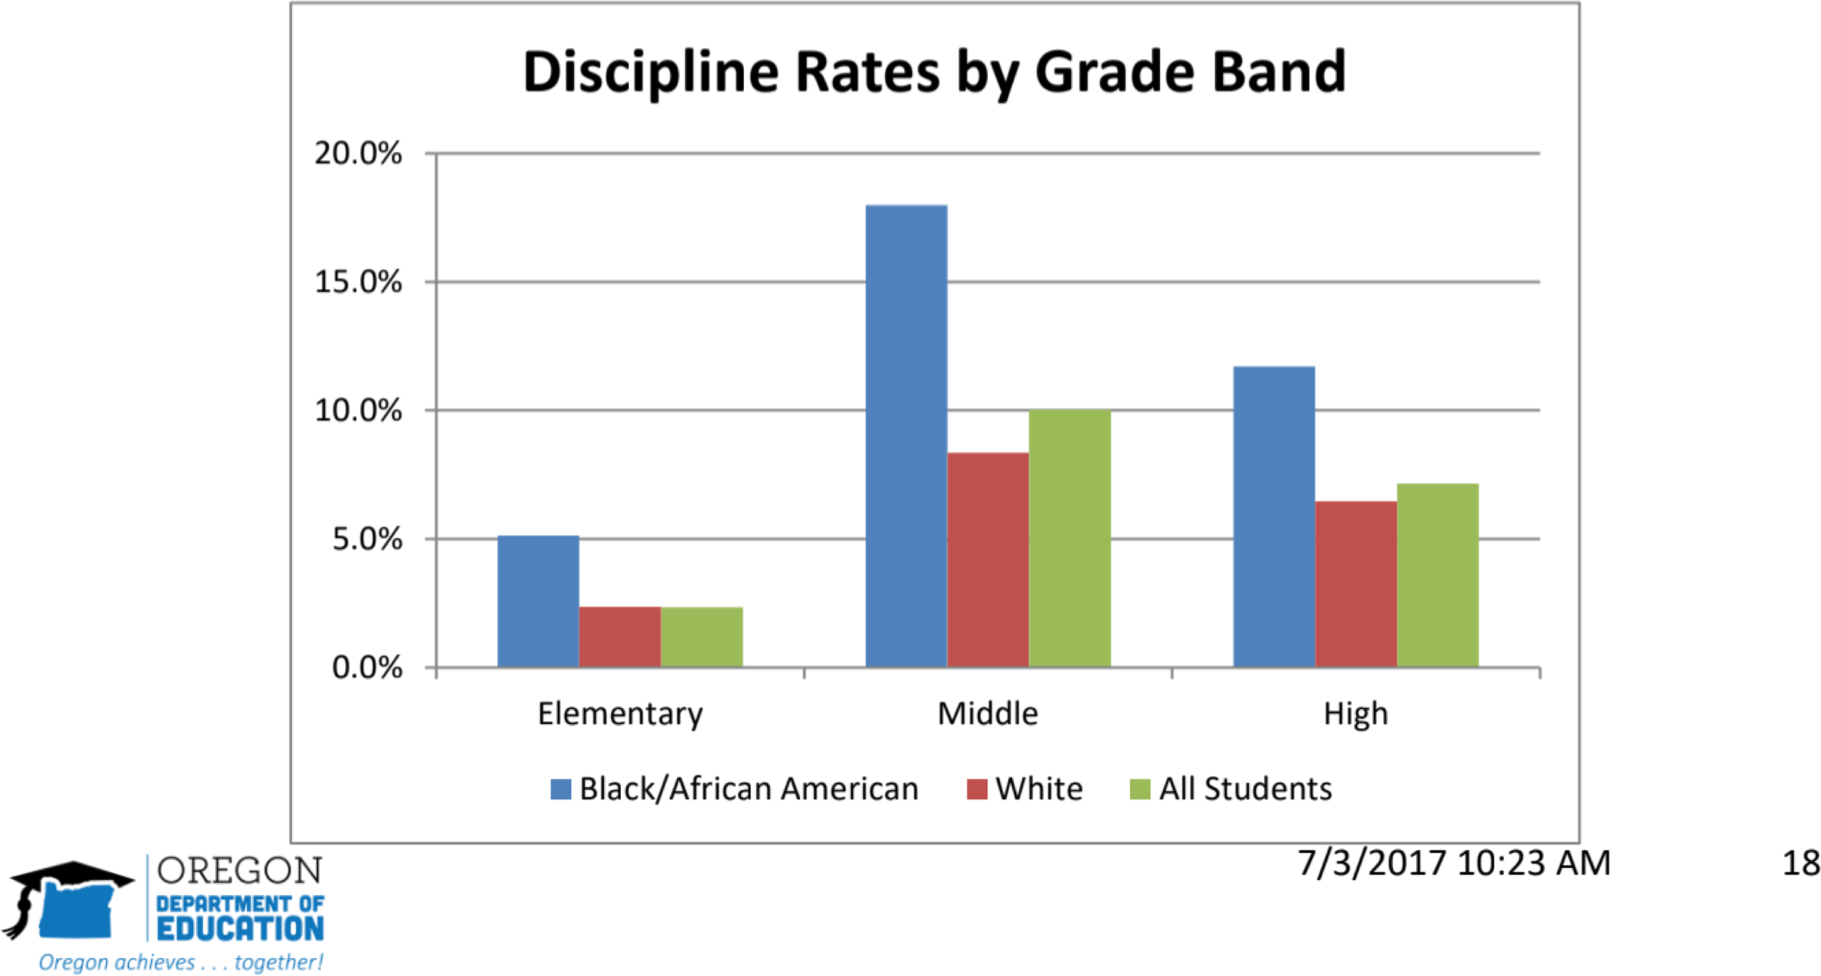

Colorblind
This ideology is rooted in a belief that in order to end racial prejudice and discrimination that we don’t see people’s color, and that we just see them as people. If we remove race from our mental make up, and we just see people as human beings and then racial prejudice will disappear.

A Changing (?) Nation of Teachers
(U.S. Dept. of Education, 2020)

In 2018-2019, teachers:
100% middle class 75% women 90% monolingual

80%
60%
40%
20% | 8% | 6%
 |  |  | 2% | 1%
0%
White | African | Latino | Asian American | Native
 | American |  |  | American

In 2019, 30% of schools had ZERO teachers of color.

Be Mindful of “White Fragility”

- A state in which even a minimum amount of racial stress becomes intolerable, and uncomfortable triggering a range of defensive moves.

- Many whites are infrequently challenged & have less of a tolerance for race based stress, and become defensive, guilty, hostile, fearful (and tearful) when confronted. Hence, the term “White fragility”

Turn and Talk !

Why are people uncomfortable discussing race?

Why are People of Color more likely to acknowledge or discuss race and racism issues than White people are?

What steps can we take to talk more openly about race and racism?

Strategy #1--Be Honest
What are my bias?
Examine your own prejudices and values as it pertains to your own beliefs about people of color. Do I stereotype people of color? What were the messages that I received growing up about people of color?

Strategy #2--Be a Partner
Volunteer to work alongside people of color on joint projects and ventures. Research has shown that intergroup contract reduces prejudice and enhance cross racial relationships.

Strategy #3--Be an Anti-racist parent
Be active in introducing your children to interacting and earning from children of color before prejudices become solidified. Raise your children to understand concepts such as prejudice, discrimination and racism

Strategy #4--Be an Ally
Reach out, support victims of discrimination and racism; be willing to join them in advocating for fair and equitable treatment. Speak out when you see racial discrimination.

Strategy #5—Be an activist

When you see racial injustice speak out and object. Be willing to challenges your family, friends, colleagues and neighbors when they make racial jokes or slurs or act in ways that indicate stereotypes or bias.

Strategy #6—Be secure

Do not be ashamed of your cultural heritage. Try to understand it. Do recognize the positive and negative aspects of your group. Take a stance in defining your own whiteness in a non- racist manner and live by these tenets

Strategy #7—Be a student !

Educate yourself and others on an ongoing basis, reading books, seeing movies, and going to hear People of Color speakers to enlighten, broaden and educate yourself on realities different from your own.

Addressing Anti-Black Racism
Anti-blackness has to be classified separately from racism and given its own prominence. The one-size- fits-all approach to tackling racism leaves under supported the racial group which suffers the most brutality, hatred and discrimination. Furthermore, in white-dominant societies, blackness has come to be a synonym for crime, laziness, poverty and low intelligence

Examples of Anti-Black Racism
- Silencing of Black people and Black youth
- Objectifying bodies and hair of Black people
- Operating on stereotypes about Black people
- Accepting common usage of the N- Word
- Assuming pathology and low intelligence of Black children and families

Disrupting Anti Blackness Step 1

Believe Black Youth. In much of the way that the MeToo movement has been centered on the oppression, assaults, and abuse of women, a common call has been to believe the stories of women when they tell them. The same can be said when Black people and students speak to issues of race, racism, discrimination and prejudice. Place faith and belief in Black people’s struggles, stories, pain, and challenges to be see as equals in a society that often posits them as less than equal.

Disrupting Anti Blackness Step 2
Advocate for Black youth. When in situations pertaining to Black children, there is a power in members from other groups advocating for, speaking up for, or supporting the needs and concerns of Black children. In many instances, when issues around Black children come about in schools, Black faculty, staff, or administrators are expected to do the emotional lifting to explain why and how Black students are treated unfairly or not being provided equitable opportunities. It is vital that non-Black teachers, staff and administrators think about and speak up for the opportunities of Black students.

Disrupting Anti Blackness Step 3
Disrupt untruths and stereotypes about Black children and families. The persistence of stereotypes often leads to the pervasiveness of untruths and inaccurate depiction of populations. Eliminating anti- blackness must be situated in ongoing efforts to challenge deficit, pathological or stereotypical accounts of Black life, Black culture, and Black people and children.

Disrupting Anti Blackness Step 4
Try to remain aware of uninformed bias towards Black people. An increasing amount of scholarship has been centered on the salience of implicit bias. Calling out microaggressions and unfair comments, and inaccurate criticisms towards Black children should become normalized. Moreover, it is vital that white people call out such acts when they see them occurring.

Disrupting Anti Blackness Step 5
Identify and speak about Black excellence. So much of anti-blackness is steeped in the pathological depiction of Black people, culture, and history. Often absent in anti-Black sentiment is the unbridled excellence that exists in many schools, homes, and communities. It is vital for teachers, researchers, and school leaders to identify and discuss Black excellence, thriving Black schools, communities, and high achieving Black students. A growing number of scholars are examining counter narratives to change the arc of how Black life is depicted in research and practice.

Racial Micro-aggressions
- Microaggressions are brief and commonplace verbal, behavioral, or environmental indignities, whether intentional or unintentional, that communicate hostile, derogatory, or negative slights and insults towards people of marginalized groups.

- Perpetrators of micro-aggressions are often unaware that they engage in such communications when they interact with people of marginalized groups.

- Microaggressions cut across all social identities.

- Intention does not always equal IMPACT

Source: Sue, Capodilupo, Torino, Bucceri, Holder, Nadal, & Esquilin (2007). Racial microaggressions in everyday life. American Psychologist, 62(4), 271-286.

Colorblind

This ideology is rooted in a belief that in order to end racial prejudice and discrimination that we don’t see people’s color, and that we just see them as people. If we remove race from our mental make up, and we just see people as human beings and then racial prejudice will disappear.

King Johnson - 9 Years Old

“Today was not a good learning day. blah blah blah. i only wanted to hear you not talking. You said something wrong and i can’t listen when I hear lies. My mom said that the only Christopher we acknowledge is Wallace (aka Notorious BIG). Because Columbus didn’t find our country, Indians did. I like to have Columbus day off but I want you to not teach me lies. That is all. My question for the day is how can white people teach black history?” - King Johnson

“King, I am very disappointed in your journal today.”

“ok.”

A Pedagogy of Poverty

- Giving information
- Assigning homework
- Asking yes/no questions
- Constant ditto sheets
- Giving constant directions
- Settling disputes
- Giving low level tasks
- Punishing for minor
- Showing DVD/Videos
- Low level busy work
- Excessive testing issues
- Going over tests
- Teaching to the test
- Grading papers

M. Haberman. “The Pedagogy of Poverty vs. Good Teaching” Phi Delta Kappan 1991. 290-294.

A Pedagogy of Plenty

• Authentic tasks
• Meaning-driven curriculum
• Literacy-rich environment
• Quality resources
• Connecting school with home, culture and community
• Problem-focused learning
• Cognitive and metacognition in the context of purposeful activities
• Collaborative work on issues of deep concern to the students
• Varied social configuration
• Engagement in substantive dialogue, discussion, debate about the substance of content
• Making meaning

Helen Hodges. “Overcoming a Pedagogy of Poverty” R. Cole, Ed. More Strategies for Educating Everybody’s Children, ASCD, 2001, p.1-9.

Racial Violence in Schools

Mental Health Challenges are Real!
20 million youth have experienced some type of traumatic event within the past year
Child Mind Institute, 2019

“No significant learning can occur without a significant relationship.”

-James Comer Psychiatrist

Understanding Cognitive Science

Neuroscientists studies show that the brain is a social organ. The brain develops within the context of attachment relationships. Relationships influence neuroplasticity which connects the brains capacity to change, comprehend, think & learn (Lieberman, 2016)

